**ExCEL Merchandise Sale!**

***All proceeds support the ExCEL program, including a scholarship for a senior.***

3 Designs to Choose From:*

**Grey ExCEL**

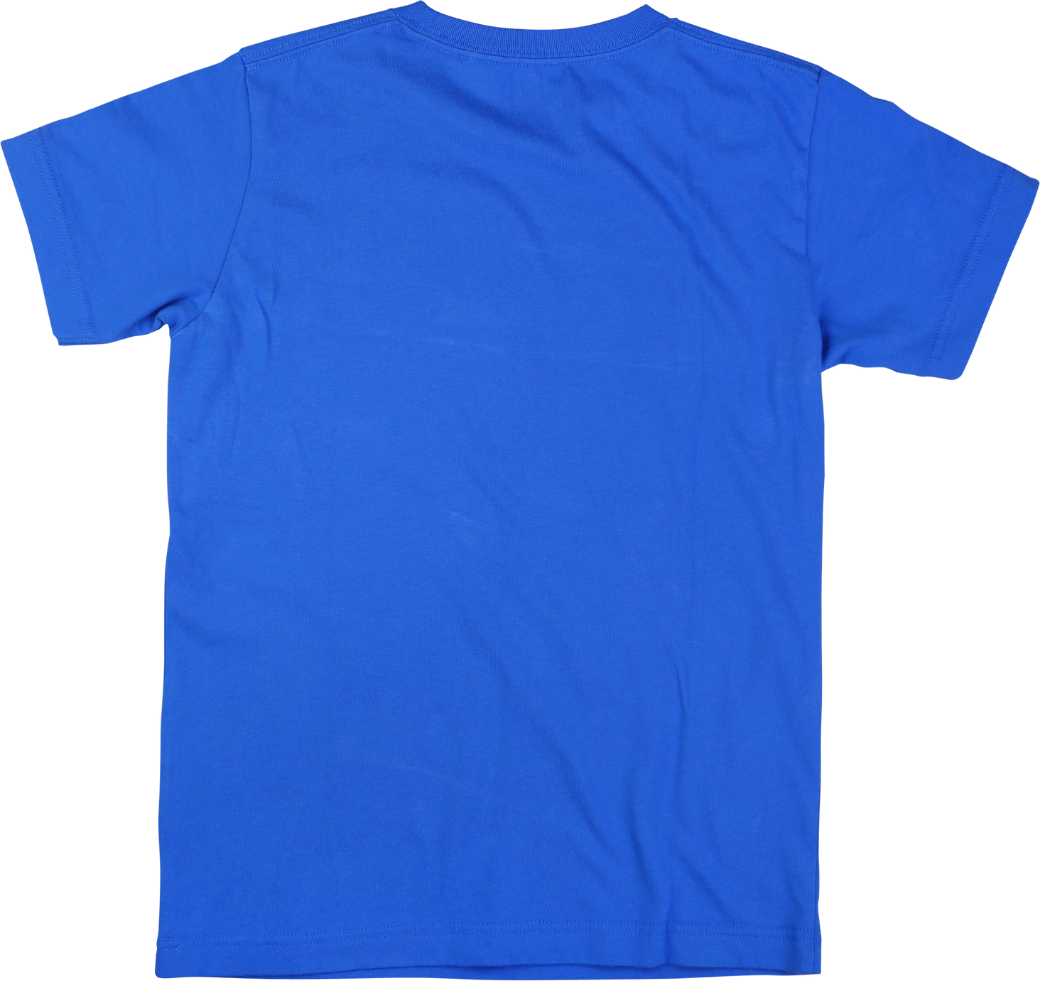

**Largo Crest**

**ExCEL Logo**

***T-SHIRTS $20***

***HOODIES $ 40***

***Most Sizes In Stock!***

***Order in the ExCEL office or online, then stop by for pick up!***

***Click the link for either a*** [***shirt***](https://pcsb.revtrak.net/hs/largo-high/lhs-clubs-and-classes/#/v/lhs-ebsa-t-shirt) ***or*** [***hoodie***](https://pcsb.revtrak.net/hs/largo-high/lhs-clubs-and-classes/#/v/LHS-EBSA-Hoodie) ***for online payment.***

*Online payments charged non-refundable 3.25% processing fee*